Title: Chemistry-Enabled Molecular PET Imaging of Brain Health and Disease
题目：化学驱动的脑健康与疾病分子PET影像研究
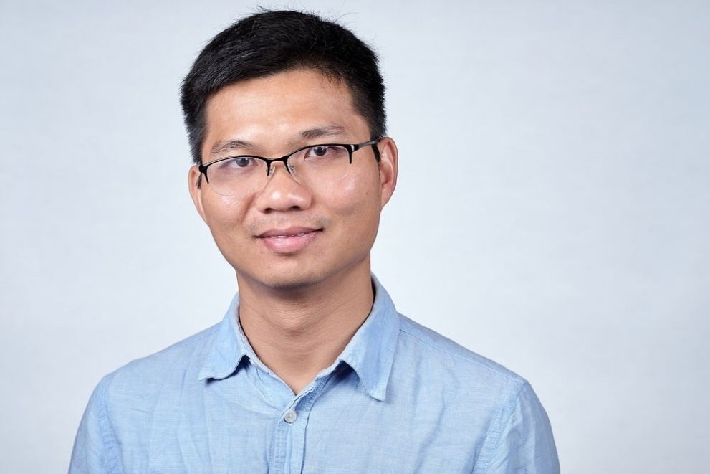

郑超博士现任加拿大成瘾与精神健康研究所（Centre for Addiction and Mental Health, CAMH）脑健康影像中心及 Azrieli 神经放射化学中心独立科学家，并任加拿大多伦多大学三个系：精神病学系、化学系及药理学与毒理学系助理教授，同时为多伦多大学医学科学研究所、神经科学协同项目及 Acceleration Consortium 的教职成员。
郑超博士具有有机化学、药物化学、放射化学、正电子放射性药物、PET 神经影像及分子影像神经科学等多学科研究背景。本科毕业于中国科学技术大学，博士毕业于北京大学，随后先后在美国哈佛大学医学院/麻省总医院 Martinos 生物医学影像中心以及及耶鲁大学开展博士后及科研工作，并于 2021–2023 年任耶鲁大学医学院 Associate Research Scientist。2023 年加入 CAMH 和多伦多大学并建立独立研究团队。
郑超博士的研究聚焦于脑疾病分子影像与放射化学方法学创新，致力于开发新型 PET 放射性药物和定量分子影像技术，以实现对神经退行性疾病、神经炎症及精神疾病关键生物学过程的无创检测，并推动新型分子探针从放射化学与药物化学发现、临床前验证到人体转化研究。近年来，他在突触分子影像、神经退行性疾病生物标志物以及新型碳-18F 放射化学方法等方向取得了一系列研究进展，相关成果发表于 PNAS、Nature Communications、Science Advances、ACS Catalysis、European Journal of Nuclear Medicine and Molecular Imaging、Journal of Nuclear Medicine 等国际学术期刊，并形成多项具有转化潜力的分子探针和技术创新。
其研究获得美国国立卫生研究院（NIH）、加拿大卫生研究院（CIHR）、加拿大自然科学与工程研究理事会（NSERC）、阿尔茨海默病协会（Alzheimer's Association）及其他国际科研机构和基金会的持续资助。作为独立PI，他已主持多项加拿大国家级及国际科研项目，同时参与多项 NIH、美国国防部及国际合作研究计划。
郑超博士于2026年获得加拿大安大略省政府青年研究者奖（Ontario Early Researcher Award）。郑超教授的科研工作获得了多个国际专业学术组织的认可，曾多次获得核医学与分子影像学会（Society of Nuclear Medicine and Molecular Imaging, SNMMI）青年研究者相关奖项，并入选“2024 SNMMI Ones to Watch”。他还曾获得阿尔茨海默病协会国际会议奖学金及多项青年科学家和国际研究交流奖项。
除科研工作外，郑超教授长期参与国际学术服务，担任多个国际学术期刊编辑或审稿人，并参与 NIH、CIHR、Alzheimer's Association 等科研基金的同行评审工作，同时担任国际学术会议专题分会的组织者和共同主席。近年来，他多次受邀在北美、欧洲及亚洲的重要国际会议、大学、研究机构和医学中心作学术报告，介绍其在放射化学、PET 分子影像及脑疾病转化研究方面的最新工作。
English version：Dr. Chao Zheng is an Independent Scientist at the Centre for Addiction and Mental Health (CAMH), affiliated with the Brain Health Imaging Centre and the Azrieli Centre for Neuro-Radiochemistry, and an Assistant Professor in the Departments of Psychiatry, Chemistry, and Pharmacology & Toxicology at the University of Toronto. He is also a faculty member of the Institute of Medical Science, the Collaborative Program in Neuroscience, and the Acceleration Consortium at the University of Toronto.
Dr. Zheng has multidisciplinary training spanning organic chemistry, medicinal chemistry, radiochemistry, positron-emitting radiopharmaceutical development, PET neuroimaging, and molecular imaging neuroscience. He received his B.Sc. from the University of Science and Technology of China and his Ph.D. from Peking University. Before joining CAMH and the University of Toronto, he conducted postdoctoral and research training at Harvard Medical School/Massachusetts General Hospital, and Yale University. From 2021 to 2023, he served as an Associate Research Scientist at Yale School of Medicine.
Since establishing his independent research program at CAMH and the University of Toronto in 2023, Dr. Zheng has focused on the development and application of innovative radiopharmaceuticals and quantitative molecular imaging approaches for brain disorders. His laboratory integrates radiochemistry, medicinal chemistry, preclinical imaging, molecular neuroscience, and translational PET to develop new tools for interrogating disease-relevant biology in neurodegenerative, neuroinflammatory, and psychiatric disorders. His work spans the discovery of new radiochemical methodologies and molecular probes through preclinical validation and, ultimately, translation to human imaging.
Dr. Zheng has made a series of contributions to molecular imaging of brain disorders, synaptic imaging, neurodegenerative disease biomarkers, and innovative carbon-11 and fluorine-18 radiochemistry. His research has been published in leading journals including Proceedings of the National Academy of Sciences of the United States of America (PNAS), Nature Communications, Science Advances, ACS Catalysis, European Journal of Nuclear Medicine and Molecular Imaging, and Journal of Nuclear Medicine. His research has also generated multiple molecular probes and technologies with potential for further translational development.
His research program has received support from major national and international funding organizations, including the Canadian Institutes of Health Research (CIHR), the Natural Sciences and Engineering Research Council of Canada (NSERC), the U.S. National Institutes of Health (NIH), the Alzheimer’s Association, and other research foundations. As an independent principal investigator, he currently leads multiple nationally and internationally funded research projects and also contributes to collaborative programs supported by the NIH, the U.S. Department of Defense, and other funding agencies.
In 2026, Dr. Zheng received the Ontario Early Researcher Award (ERA) from the Government of Ontario. Dr. Zheng’s work has been recognized through multiple awards from the Society of Nuclear Medicine and Molecular Imaging (SNMMI), including Young Investigator Awards, and he was named one of the “2024 SNMMI Ones to Watch.” He has also received fellowships and awards from the Alzheimer’s Association and other international scientific organizations supporting emerging investigators and translational neuroscience research.
In addition to his research activities, Dr. Zheng is actively involved in academic and professional service. He serves in editorial and peer-review roles for scientific journals and has participated in grant-review panels for organizations including the NIH, CIHR, and the Alzheimer’s Association. He has also served as a session organizer and co-chair at international scientific conferences. Dr. Zheng is regularly invited to present his research at international conferences, universities, academic medical centers, and research institutes across North America, Europe, and Asia.

